**City University of Hong Kong**

2017-2018 Semester A

CS3343 Software Engineering Practice

**User Manual**

Maverick:

The Smart Trading Platform

Group 14

|  |  |
| --- | --- |
| **Name** | **Student Number** |
| Dheeraj Khurana | 54227224 |
| Navwinder Singh | 54395023 |
| Ravinder Singh | 54390586 |
| Pang TSZ HO | 54387730 |
| Mathew Bilo | 54387858 |

**Maverick OnlineShop User Manual**

**Main Menu**

Upon starting up the program, you will see the following output in the console window. Here you will have 3 options, either to sign up as a user, login as a user if you had already signed up before, or exit to exit program. Please be mindful that the first letter of the commands are capital.

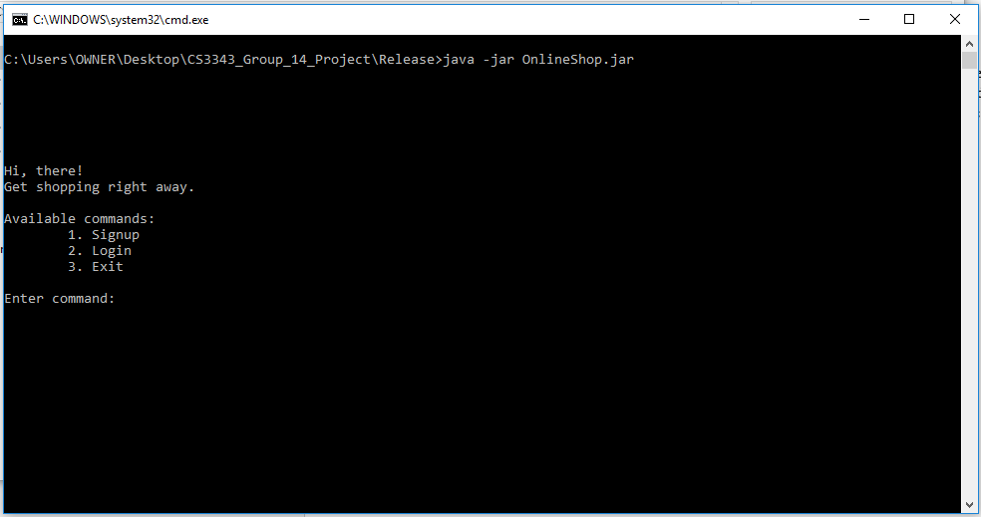

**SignUp**

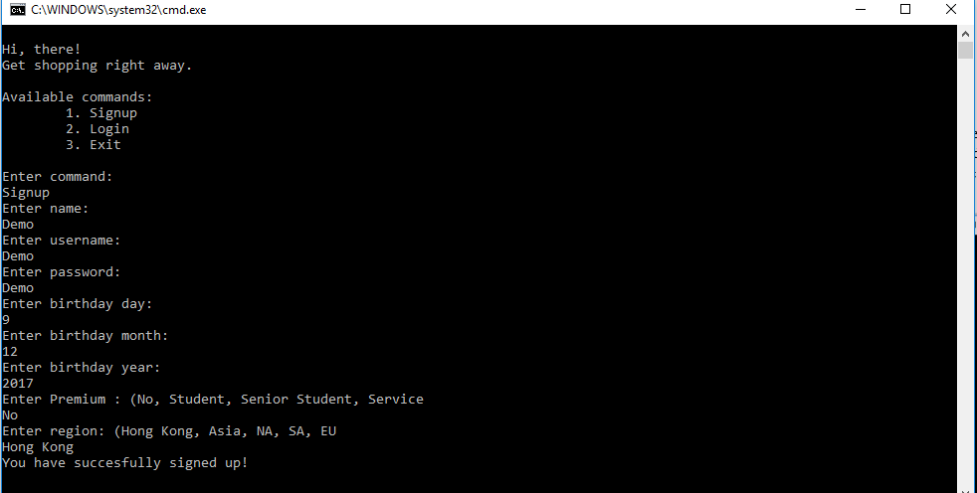Once you have entered the signup command you will be greeted with the following screen. Where you are requested to input your personal details, such as name, username, password, birthday information, your region and are you eligible for premium or not. If you have successfully signed up you will see “You have successfully” signed up!” and will be taken back to main menu.

**Login**

Upon inputting the login command, you will be requested for your username and password. If you input incorrect username and password you will be notified of unsuccessful login and returned to the main menu as shown below.

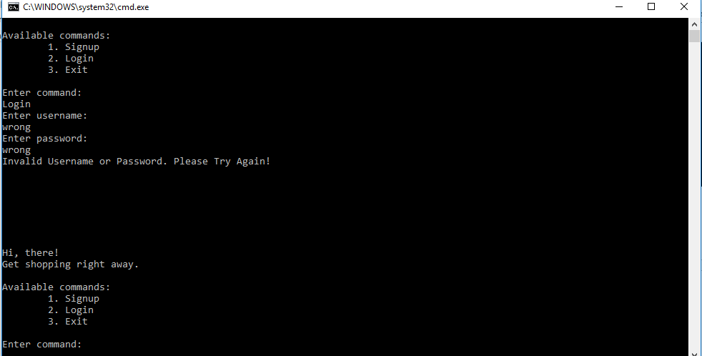

On a successful login you will see the following window where you may input further commands such as Buy, Sell, History and Logout.

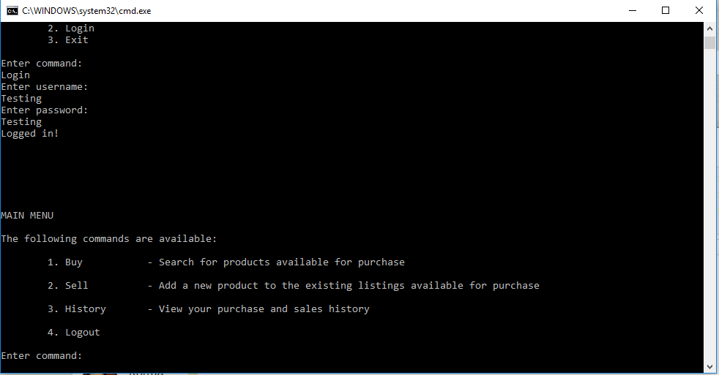

**Buy**

On the input of Buy command you will be asked to select the category of the product you wish to purchase as shown below. Then a list of available products for sale from that category will be shown. 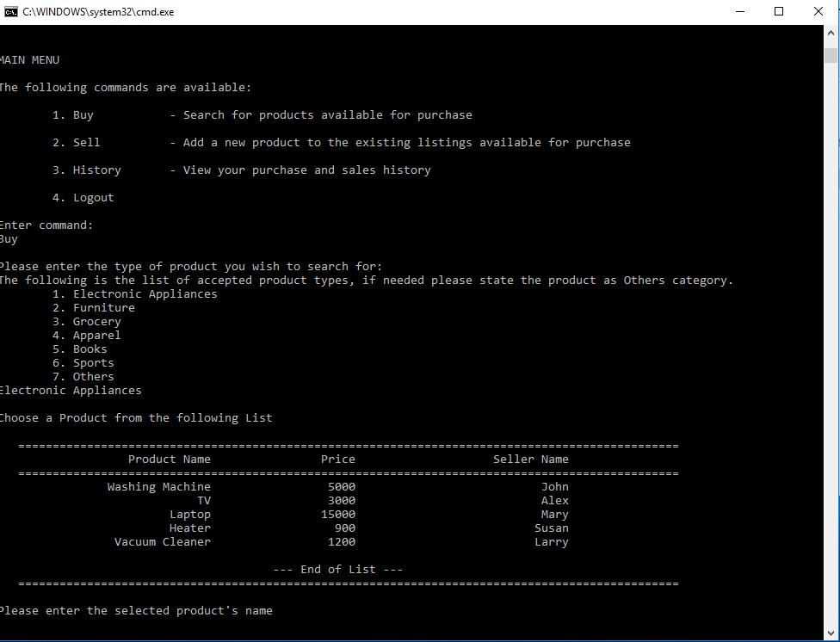

Then we can type in the products name and the seller’s name to confirm the product we wish to purchase as and In order to address functional requirements of the program, such as giving discounts and shipping charges, all these functions are executed at the backend, not requiring any effort from the user, for example in the screenshot below the user purchases a TV which costs HKD 3000, however he only needs to pay 900 dollars because of all available discounts to the user. Also, the maximum discount a user can achieve is also 70%. The discounts range from basic discounts, premium discounts to seasonal discounts and birthday discount. The final price also computes in the shipping cost since the region for account “Demo” is HK, the shipping does not incur any additional costs. And finally, the program computes and outputs the users total final reward points. At 20,000 points the user redeems an Apple Watch.

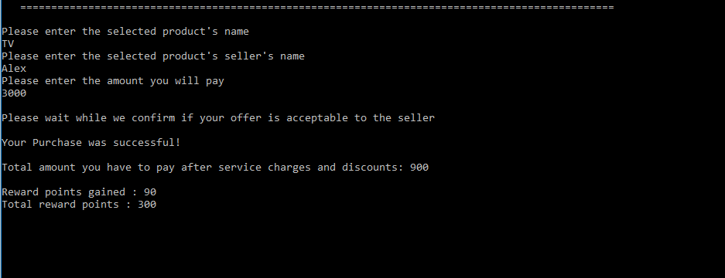

**Sell**

Using the sell command the user can list an item to be sold via the system. The user sets the product name, category it belongs to the price he wishes to sell it at and the minimum price acceptable to the user and then the program outputs the product is listed for sale. Just like in the screenshot shown below where a product Rice is created as a new listing.

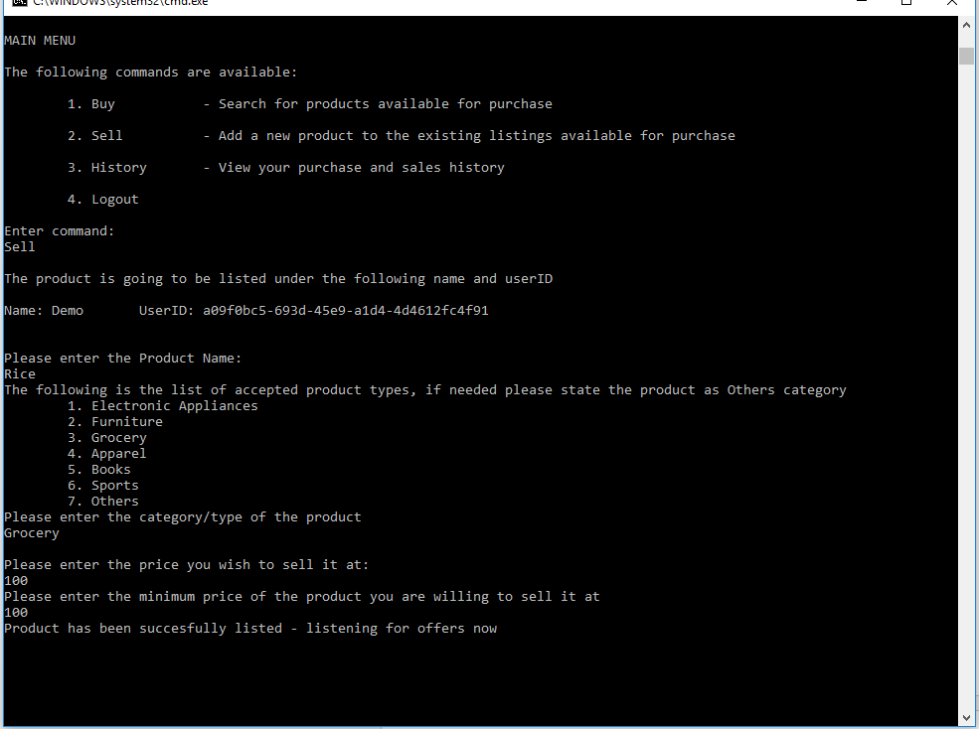

**History**

The command history does exactly what it says, it lists out the history of the user activity, in terms of items bought and sold as shown in the screenshot below. (Since the product Rice was only listed to be sold but hast actually been bought by anyone yet, it doesn’t show in the items sold list)

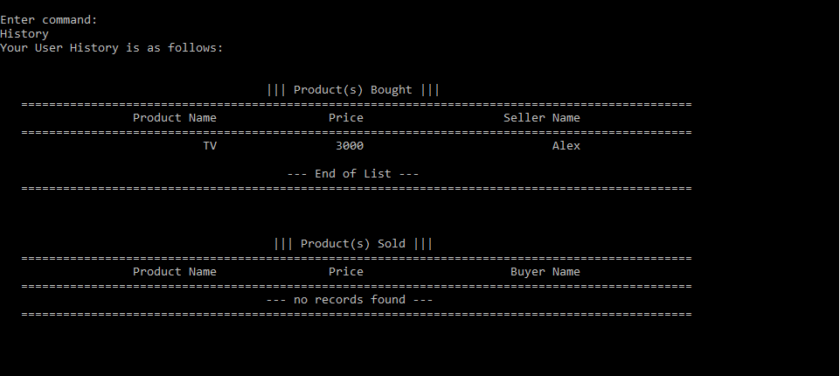

**Logout**

The logout command logs you out of the account and returns you to the Signup/Login page.

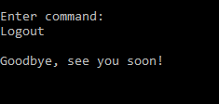

**Exit**

Upon typing the Exit command in the main menu, you will see the following message “Goodbye, see you soon!” and will be required to press any key for the console window to close, just like in the image below.

